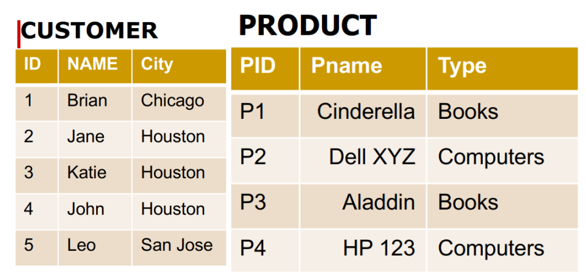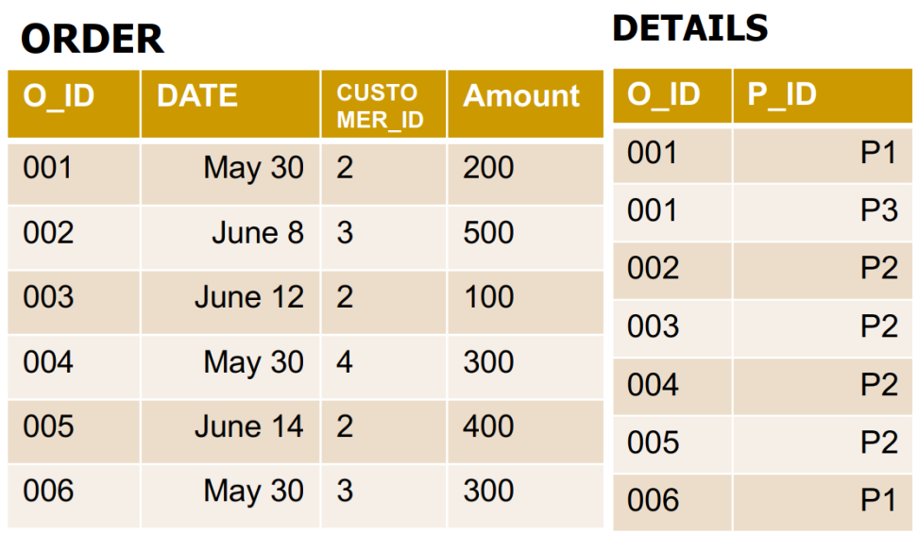
Find all customers in Chicago
$$σ_{city=^{'}Chicago^{'}}(customer)$$
Find name of customers who don’t make any order.
$$Π_{name}\left(customer\right)- Π_{name}(customer⋈order)$$
Find name of products which have never been sold.
$$Π_{Pname}\left(product\right)- Π_{Pname}(product⋈details)$$
Find name of customers who have bought all books.
$$Π_{name}\left(σ_{type=^{'}Books^{'}}(customer⋈order⋈details⋈product)\right)$$
Find name of computers which has been sold in May 30.
$$Π_{Pname}\left(σ_{date=^{'}May{ 30}^{'}}(product⋈details⋈order)\right)$$

R(ABCDEI)
F = {A → C, AB → C, C → DI, CD → I, EC → AB, EI → C}
Find the minimal cover?
B1:
F’={A->C, AB->C, C->D, C->I, CD->I, EC->A, EC->B, EI->C}
B2:
A->C: (chon)
A+ = AC = ACD = ACDI
A+ = A
AB->C: (khong chon)
AB+ = ABC = ABCD = ABCDI
AB+= AB = ABC = ABCDI
F’={A->C, C->D, C->I, CD->I, EC->A, EC->B, EI->C}
C->D: (chon)
C+ = CD = CDI
C+ = C = CI
C->I: (khong chon)
C+ = CI = CDI
C+ = C = CD = CDI
F’={A->C, C->D, CD->I, EC->A, EC->B, EI->C}
CD->I: (chon)
CD+ = CDI
CD+ = CD
EC->A: (chon)
EC+ = ECA = ECAD = ECADI = ECADIB = R
EC+ = EC = ECD = ECDI = ECDIB # R
EC->B: (chon)
EC+ = ECA = ECAD = ECADI = ECADIB = R
EC+ = EC = ECD = ECDI = ECDIA #R
EI->C: (chon)
EI+ = EIC = EICD = EICDA = EICDAB = R
EI+ = EI
=> F’={A->C, C->D, CD->I, EC->A, EC->B, EI->C}
B3:
CD->I: CDI
C->I: C+ = CI = CID
D->I: DI+ = DI
=> F’={A->C, C->D, C->I, EC->A, EC->B, EI->C}
EC->A: ABCDEI = R
E+ = E
C+ = CD
EC->B:
E+ = E
C+ = CD
EI->C:
E+ = E
I+ = I
So, the minimal cover:
F’ ={A->C, C->D, C->I, EC->A, EC->B, EI->C} = {A->C, C->ID, EC->AB, EI->C}
Find the Normal Forms?
EA+ = EAC = EACD = EACDIB = R
EC+ = ECAB = ECABD = ECABDI = R
EI+ = EIC = EICD = EICDAB = R
P: EA, EC, EI NP: BD
2: prime->non-prime: có C->D => 1NF

